**Name –Supriya kapse**

**Roll no. - 38**

**Cloud Computing Practical no. 4**

**Implement Application with Google App Engine(GAE)**

step 1 – Download openJDK 11 and Eclipse Latest version and set JDK 11 in Environment Variable.

step 2 – Install Eclipse and choose VM java 11 during installation process

step 3 – After installation choose your workspace directory

step 4 – Open Eclipse and choose Help>Marketplace

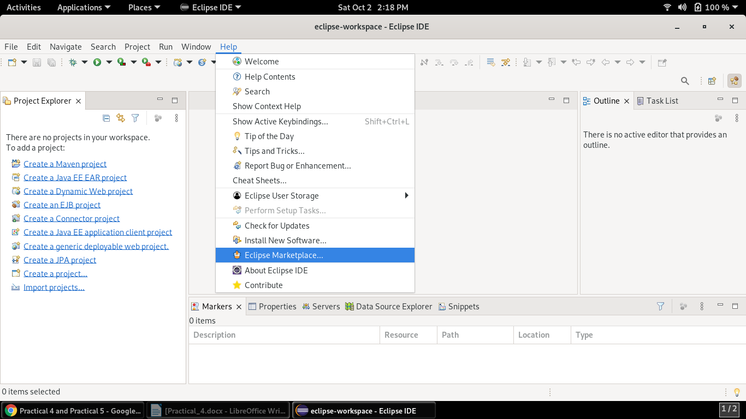

step 5 – Search for Google App Engine and Click Install

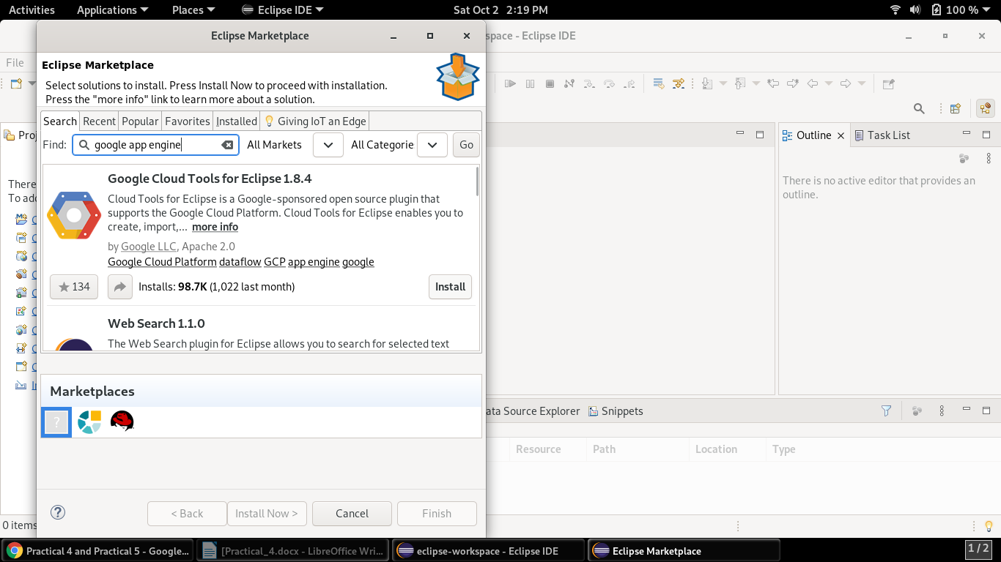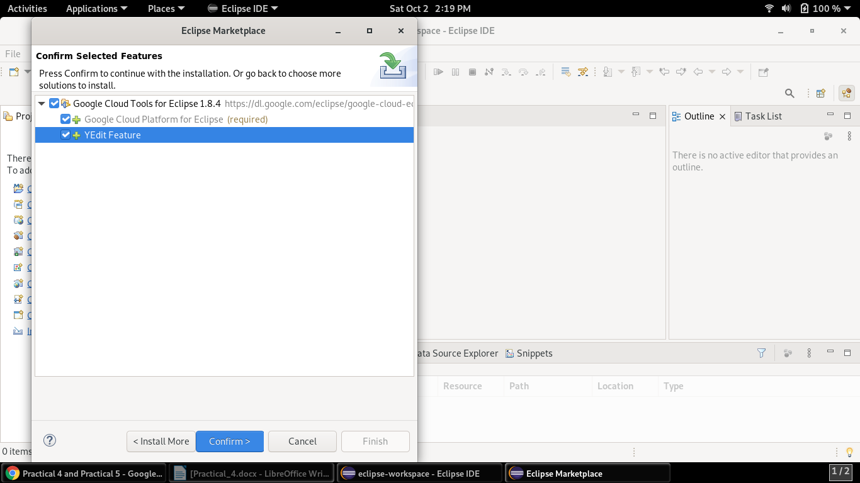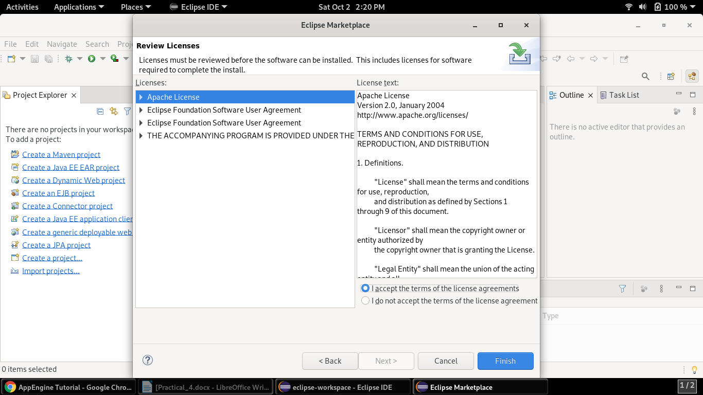

step 6 – After installing GAE if pop-up comes for Google Cloud SDK installation then install.

Step 7 – Restart Eclipse after installing GAE and Cloud SDK

step 8 – go to File Menu

Step 9 – New>Other

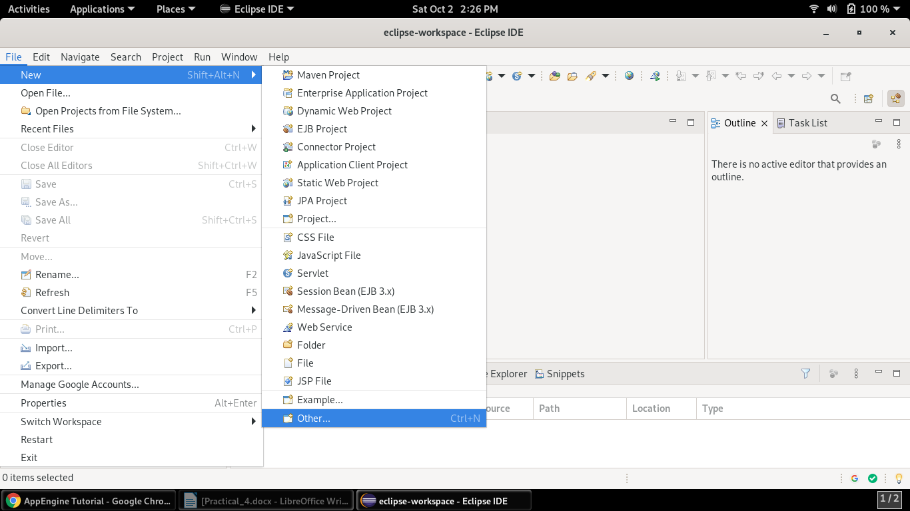

step 10 – Choose Google Cloud Platform > GAE Standard Java Project

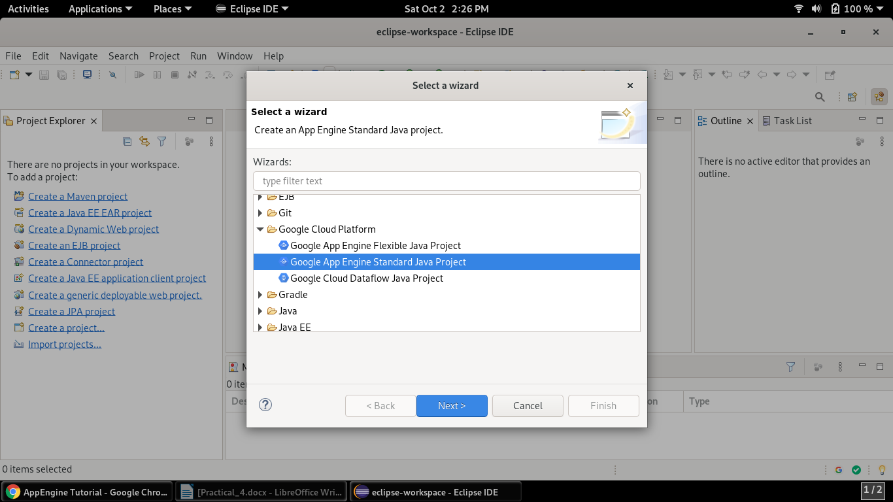

step 11 – give Project Name – addMultiply and Package as com.addMulti

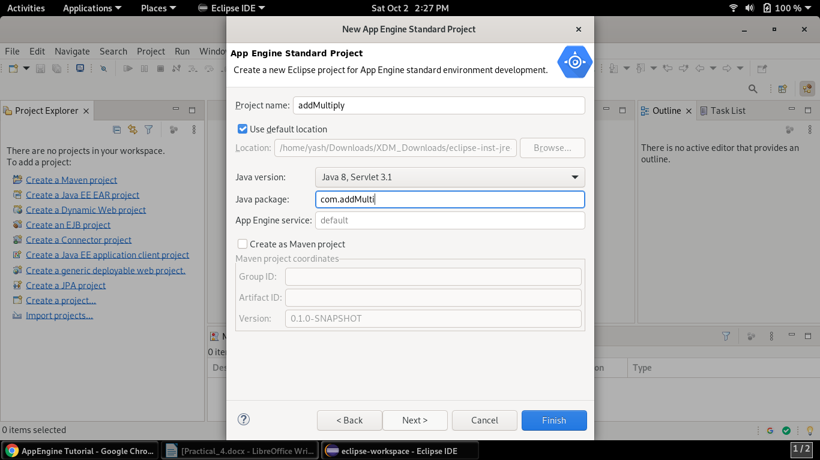

step 12 – Choose Libraries if any in our case it none

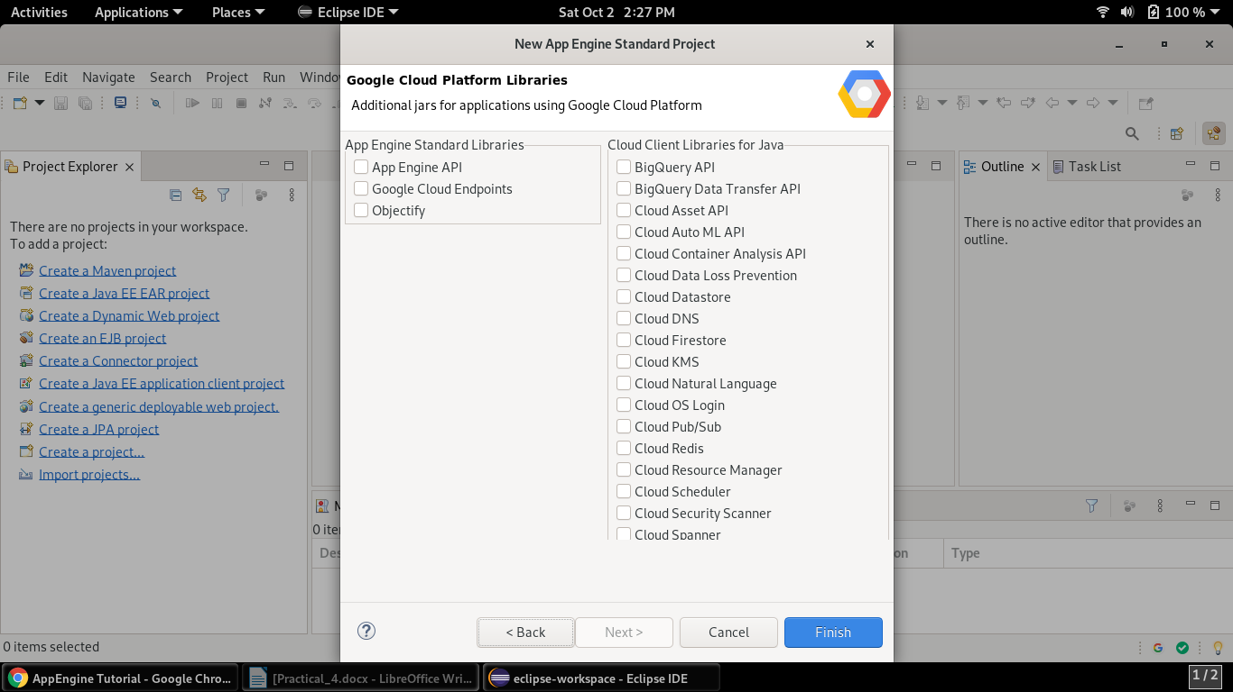

step 13 – Open Project folder and choose open HelloAppEngine.java, index.html and web.xml

step 14 – Type code given below in these files

HelloAppEngine.java

**package** com.addMulti;

**import** java.io.IOException;

**import** java.io.PrintWriter;

**import** javax.servlet.annotation.WebServlet;

**import** javax.servlet.http.HttpServlet;

**import** javax.servlet.http.HttpServletRequest;

**import** javax.servlet.http.HttpServletResponse;

@WebServlet(

name = "HelloAppEngine",

urlPatterns = {"/hello"}

)

**public** **class** HelloAppEngine **extends** HttpServlet {

@Override

**public** **void** doGet(HttpServletRequest request, HttpServletResponse response)

**throws** IOException {

**int** num1 = Integer.*parseInt*(request.getParameter("num1"));

**int** num2 = Integer.*parseInt*(request.getParameter("num2"));

**int** sum = num1 + num2;

**int** product = num1 * num2;

PrintWriter output = response.getWriter();

output.println("The Answer :"+sum +"\n The product :"+product);

}

}

index.html

<!DOCTYPE html>

<html xmlns=*"http://www.w3.org/1999/xhtml"* lang=*"en"*>

<head>

<meta http-equiv=*"content-type"* content=*"application/xhtml+xml; charset=UTF-8"* />

<title>Google App Engine</title>

</head>

<body>

<h1>Google App Engine!</h1>

<form action=*"add_me"*>

<label>First number </label> <input type=*"text"* name=*"num1"*/> <br/><br/>

<label>Second number </label> <input type=*"text"* name=*"num2"*/> <br/><br/>

<button type=*"submit"* name=*"calculate"*>Product and Sum </button><br/>

</form>

</body>

</html>

web.xml

<?xml version=*"1.0"* encoding=*"utf-8"*?>

<web-app xmlns=*"http://xmlns.jcp.org/xml/ns/javaee"*

xmlns:xsi=*"http://www.w3.org/2001/XMLSchema-instance"*

xsi:schemaLocation=*"http://xmlns.jcp.org/xml/ns/javaee http://xmlns.jcp.org/xml/ns/javaee/web-app_3_1.xsd"*

version=*"3.1"*>

<welcome-file-list>

<welcome-file>index.html</welcome-file>

<welcome-file>index.jsp</welcome-file>

</welcome-file-list>

<servlet>

<servlet-name>Add</servlet-name>

<servlet-class>com.addMulti.HelloAppEngine</servlet-class>

</servlet>

<servlet-mapping>

<servlet-name>Add</servlet-name>

<url-pattern>/add_me</url-pattern>

</servlet-mapping>

</web-app>

step 15 – save files and choose Server option and create server

step 16 – keep all option default but make sure to choose App Engine Standard in Select the Server Type menu, Click Next

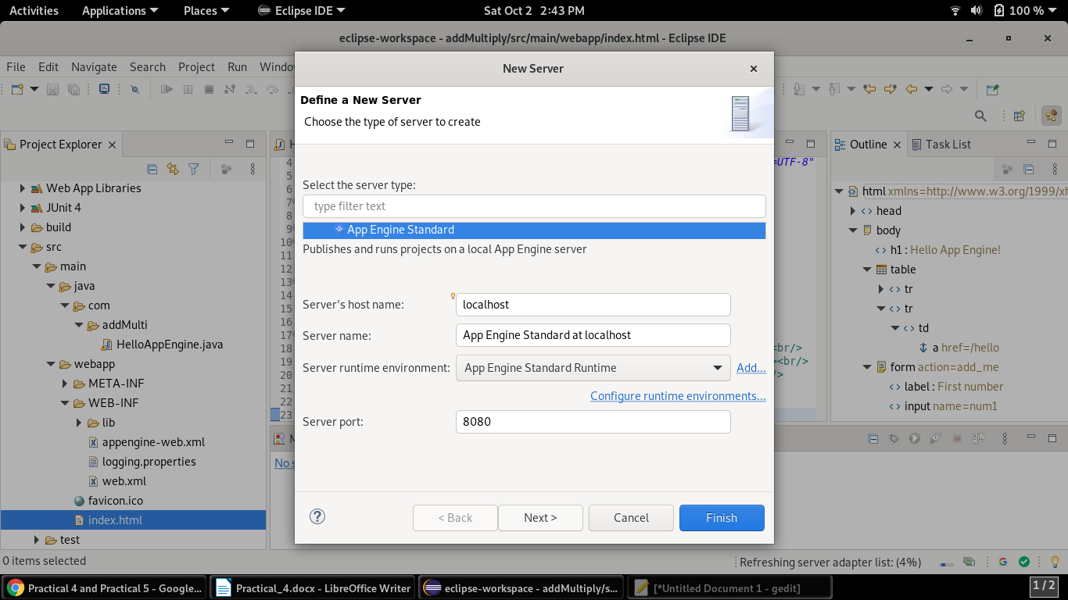

step 17 – Select addMultiply for Available menu and click Add button

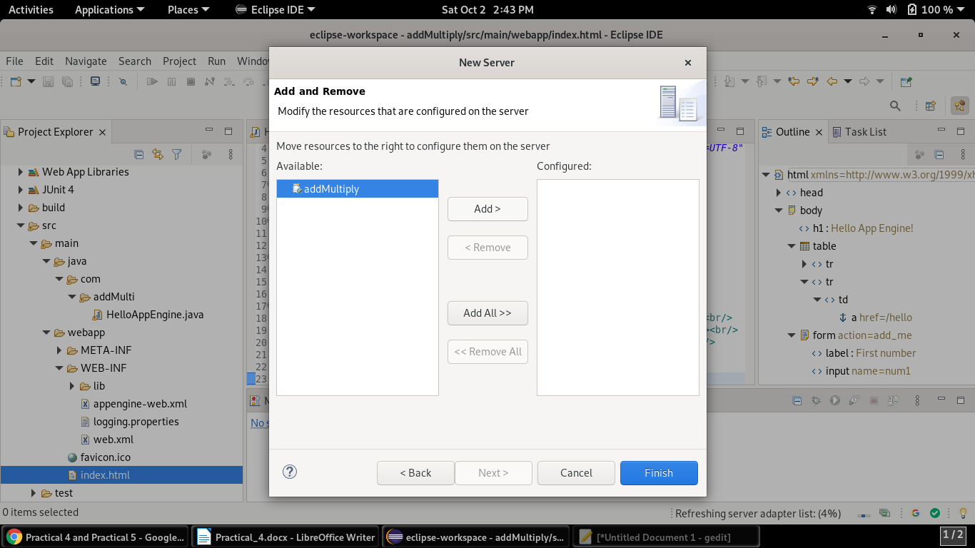

step 18 – Click Finish

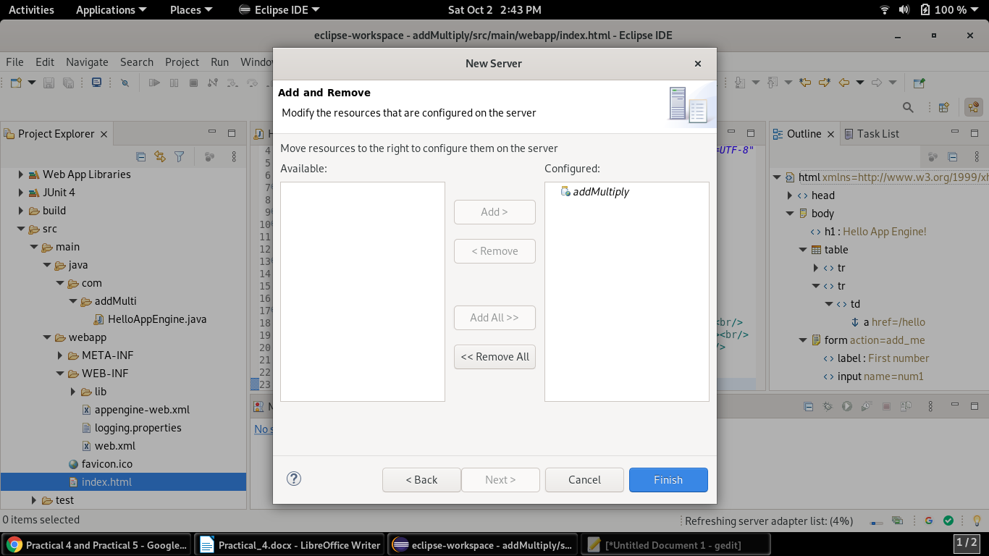

step 19 – right click on newly created server and select start option

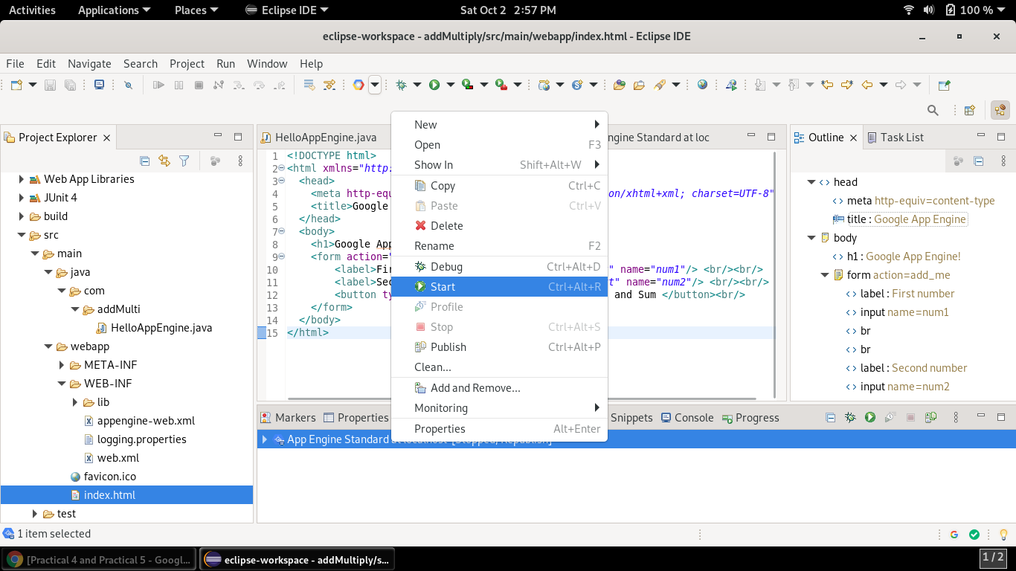

step 20 – now server has started and app engine will launch in eclipse inbuilt browser.

Output

